## 

## 

**ZOHA MUMTAZ**

**SU92-BSCBM-S23-007**

**SECTION : 4A(CYBER SECURITY )**

**COMPUTER NETWORK**

**PROJECT : NETWORK TOPOLOGY**

**SUBMITTED TO : DR. GOHAR MUMTAZ**

## 

## 

## 

## 

## 

## 

## 

## 

## 

## 

## 

## 

## 

## 

## 

## 

## 

## 

## 

## 

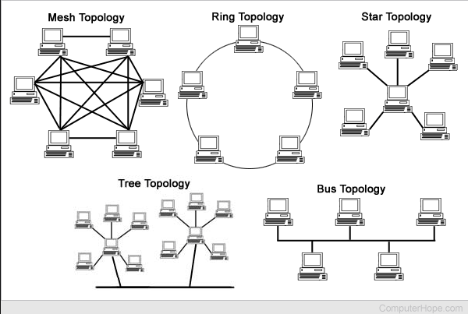

NETWORK TOPOLOGY

18-12-2024

# Overview

This document describes a network topology consisting of **three interconnected LANs**. The networks are designed for communication among devices, providing key services such as **DNS**, **Web**, **DHCP**, as well as security and traffic management features like **NAT/PAT** and **ACLs**.

The topology connects all three LANs via **routers** using serial links. Specific configurations, such as NAT/PAT on LAN 2 and ACLs to restrict access for one PC in LAN 2, have been implemented as per the network requirements.

**MY NETWORK** 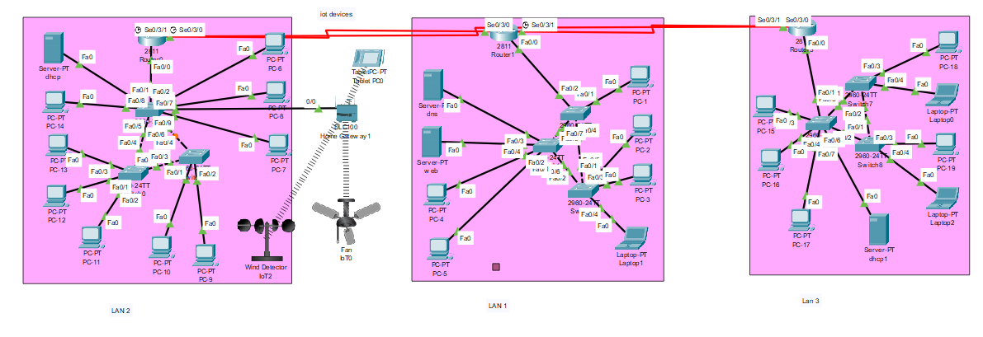

**Network Design and Components :**

The network comprises the following components:

**LAN 1: Primary Services, IoT Integration, and NAT/PAT**

* **Router**: Connects LAN 1 to LAN 2 and LAN 3.
* **Servers**:
  + **DNS Server**: Provides domain name resolution.
  + **Web Server**: Hosts web services.
* **Switches**: Connect multiple PCs, servers, and IoT devices.
* **End Devices**:
  + **PCs**: PC-1, PC-2, PC-3, PC-4, PC-5.
  + **Laptop-1**: Portable device for testing connectivity.
* **Interconnection**:
  + Interfaces such as Fa0/0, Fa0/1, etc., connect PCs, servers, and IoT devices.

### **LAN 2: DHCP Configuration**

* **Router**: Connects LAN 2 to LAN 1 and lan 3 via a serial link.
* **Servers**:
  + **DHCP Server**: Automatically assigns IP addresses to end devices.
* **Switches**: Provide connectivity for PCs and other devices.
* **End Devices**:
  + **PCs**: PC-6, PC-7, PC-8, PC-9, PC-10, PC-11, PC-12, PC-13, PC-14.
* **IoT Devices**:
  + **Wind Detector** and **Fan (IoT)** for demonstrating IoT integration.
* **Configuration**:
  + **NAT/PAT**: Configured to allow multiple devices in LAN 1 to share a single public IP address for internet access.
* **Connectivity**:
  + PCs connect through the switch to the router, which routes traffic to LAN 1 and LAN 3.

#### **LAN 3: ACL Implementation and Traffic Control**

**Router**: Connects LAN 3 to LAN 1 and LAN 2 via serial links.

**Servers**:

* **DHCP Server**: Provides dynamic IP addressing.

**Switches**: Allow devices in LAN 3 to communicate internally.

**End Devices**:

* **PCs**: PC-15, PC-16, PC-17, PC-18, PC-19.
* **Laptops**: Laptop-2, Laptop-3.

**Configuration**:

* **ACLs (Access Control Lists)**:
  + Blocks traffic from a specific PC in LAN 2 (e.g., PC-6) from accessing LAN 3.
* **Purpose**:
  + Ensure security by restricting specific PCs or devices from accessing LAN 3 while allowing other devices to communicate.

### **4. Routing Protocol :**

To ensure proper interconnectivity and dynamic routing between the three LANs, a routing protocol such as **RIP (Routing Information Protocol)** or **EIGRP (Enhanced Interior Gateway Routing Protocol)** can be configured.

### **5. Security Features**

1. **Access Control Lists (ACLs)**:
   * ACLs on **LAN 3 Router** block specific traffic from LAN 2, such as PC-6, while allowing all other traffic.

|  |
| --- |

**NAT/PAT**:

* Configured on LAN 1 Router to allow multiple devices to share a single public IP for internet access.

|  |
| --- |

Here’s the summary table reflecting the new configurations and services:

### **Network Summary Table**

| **LAN** | **Service** | **Detail** |
| --- | --- | --- |
| LAN 1 | DNS-SERVER | Resolves domain names to IP addresses. |
|  | Web Server | Hosts web applications. |
|  | NAT OR PAT | Provides internet access by sharing a single public IP. |
|  | IoT Integration | IoT devices like **Wind Detector** and **Fan** are connected. |
|  | END DEVICES | PCs (PC-1 to PC-5) and Laptop-1. |
|  | Connectivity | Devices connect via switches and are routed to LAN 2 and LAN 3. |
| LAN 2 | DHCP SERVER | Automatically assigns IP addresses to end devices. |
|  | END DEVICES | PCs (PC-6 to PC-14). |
|  | Connectivity | Connects to LAN 1 and LAN 3 via serial link. |
| LAN 3 | DHCP-SERVER | Provides dynamic IP addressing for LAN 3 devices. |
|  | ACLS | Blocks traffic from one specific PC in LAN 2 (e.g., PC-6). |
|  | End Devices | PCs (PC-15 to PC-19) and Laptops (Laptop-2, Laptop-3). |
|  | Connectivity | Devices connect internally through switches and via routers. |

**IP PLAN SCHEME LINK :**

<https://1drv.ms/x/c/416488a447bcb74c/EUUmHCaPgtZCi-_TvewmnkYBelWHYZG6vGnAC8bWhkvjzA?e=dUJMLF>

**FILE LINK**

[**https://1drv.ms/u/c/416488a447bcb74c/EYuWI0cqRyxOt1JmF1tjJdMBydkk8koz2fx-cOm4D5QGZg?e=6N2vw9**](https://1drv.ms/u/c/416488a447bcb74c/EYuWI0cqRyxOt1JmF1tjJdMBydkk8koz2fx-cOm4D5QGZg?e=6N2vw9)